Express.js

1. If we want to use the node.js in the server side, than the express.js is the best option for it
2. In the express.js we can easily make our API very easily
3. Express js is an server side framework
4. We can install the express js in the project by following the below steps
5. First initializing the package by the help of the **npm init**
6. Then fill up the questions that it asked
7. Then make an index.html file in which we will write the code of website
8. And than for installing write the following code in the terminal of the project

**npm install express --save**

🡪Where the nom is the node package manager and by the help of which we can install the various type of the packages in the projects

1. Now if you are working in the vs Code than install the thunder client extension otherwise you can also use the postman also
2. Thunder Client is a lightweight Rest API Client Extension for Visual Studio Code
3. The sample program of the express js in the node js is as follow :

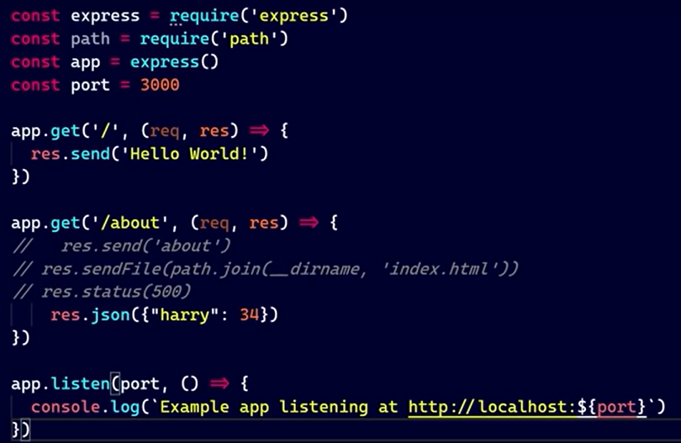

🡪Here if we want to make an request than we will use the app.get, Instead of the get we can use the post, put and many more

🡪And than in the first inverted comma, We will put the request when to make the following thing to happen, and than after comes the request and response

🡪And in response we can send the many things like the text, file, status, json and many more

🡪And we can also send the .html file also

1. In the express.js we can also use the variable or the value that is commed in the url by the help of the following things :

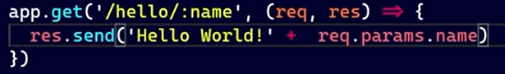

🡪Where the :name is the variable which store the name that is coming from the url

🡪And we can use this url by using the line **req.params.name**